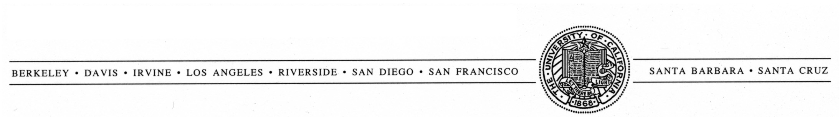
UNIVERSITY OF CALIFORNIA, SAN FRANCISCO
MATTHEW M. LaVAIL, Ph.D., DIRECTOR  KEARN FAMILY RESEARCH CENTER  FOR THE STUDY OF RETINAL DEGENERATIONS  BECKMAN VISION CENTER | UCSF SCHOOL OF MEDICINE  San Francisco, California 94143-0730  TELEPHONE: (415) 476-4233/4234  FAX: (415) 476-0709 e-MAIL: mmlv@itsa.ucsf.edu

Retinal Degeneration Rat Model Resource

Availability of P23H and S334ter Mutant Rhodopsin Transgenic Rats
and
RCS Inbred and RCS Congenic Strains of Rats

***Requests for experimental rats with inherited retinal degenerations require only a single-page letter (or e-mail or FAX) with subsequent follow-up by our group (see pp. 2-4). The remainder of this information is for your use, as needed.***

CONTENTS Page
Introduction and overview (same as preceding link) 2
Initial procedure to request rats 3
Requests for tissues, special services, etc. 3
Collaborative arrangements 3
Procedures following initial request for rats 4
Shipping 4
Repeat shipments 4
Animal health 4
Legal/proprietary conditions of use for transgenic rats 5
Mutant rhodopsin transgenic rats
Production of transgenic rats with rhodopsin mutations 6
Transgenic strain terminology and available lines 6
Degeneration rates of albino transgenic rats 7
Breeding and use of homozygotes 8
Pigmented transgenic rats and degeneration rates 9
RCS inbred and RCS congenic rat strains
Inbred RCS rats 10
Congenic strains of RCS rats 10
Available lines of RCS rats 10
Breeding schemata for RCS and RCS congenic strains 10
Degeneration rates 11
Contact information 12

Retinal Degeneration Rat Model Resource

Availability of P23H and S334ter Mutant Rhodopsin Transgenic Rats
and
RCS Inbred and RCS Congenic Strains of Rats

We have developed, maintain and distribute all of the known, fully penetrant rat models of the retinitis pigmentosa type of inherited retinal degeneration. These are the following:

Mutant rhodopsin transgenic rats
• P23H mutant rhodopsin transgenic rats
-Three lines with different rates of photoreceptor degeneration
• S334ter mutant rhodopsin transgenic rats
-Five lines with different rates of photoreceptor degeneration
RCS (Royal College of Surgeons) rats with inherited retinal dystrophy
• RCS pink-eyed inbred strain
• RCS pigmented congenic strain with slowed rate of retinal dystrophy
• RCS congenic control strains of both pigmentation types, wild-type at the retinal dystrophy (Mertk) genetic locus

We have been supported by the National Eye Institute (NEI) for the past 19 years to produce and distribute breeding pairs of the rats to vision scientists. In order to facilitate rapid distribution of the transgenic rats, we have negotiated with the commercial producer of the transgenic animals a very minimal administrative procedure for proprietary matters. Thus, the following apply:

• Request for rats requires only a 1-page letter or e-mail addressing 4 questions
• No charge for the animals or tissues (except for shipping costs)
• No Material Transfer Agreement (MTA) required
• No collaboration requirement (in most cases)

We usually provide multiple breeding pairs of the rats to vision scientists. We can also provide extra animals for immediate experimental work, animals of specific ages (depending upon availability), animals with prior exposure to different lighting conditions, eyes taken at specific ages instead of rats for pilot studies and other experiments (fresh, frozen, dissected in specific ways, or fixed with special fixatives or by different methods), or other tissues (e.g., liver, spleen, brain, testis, etc.) prepared different ways.

Details of the retinal degenerations, strain terminology and history, breeding schemata, procedures for acquiring rats and tissues, and contact information are given on the following pages. A PDF file of this document can be downloaded from http://www.ucsfeye.net/mlavailRDratmodels.shtml.

Matthew M. LaVail, Ph.D. Return to Contents

Initial Procedure to Request Rats

A brief written request for rats (by e-mail, FAX or mail) should be addressed to me, Dr. Matthew LaVail, but requests may be expedited by sending them directly to Dr. Michael Matthes (see Contact Information, below). This request can be less than one page.

When the National Eye Institute (NEI) agreed to fund the retinal degeneration mutant rat resource, it required that it be involved in the distribution of the animals, much as it did previously for mutant dogs with retinal degenerations. Although the NEI will approve of your receiving the animals, we have been asked to forward a minimal justification for the rats to the NEI. Therefore, your written request for rats should include the following information:

1. The line or lines of rats you wish to receive.

2. A short description of your proposed work with the rats (this can be as short as a few sentences).

3. Statement of your institutional review board approval for the study of rats.

4. Statement of whether or not your proposed research is funded by a NEI grant (this is for NEI information only; NEI support is not required).

Please be sure to include your e-mail and telephone contact information in the letter.

Return to Contents
Requests for Tissues, Special Services, etc.

Requests for special services, such as dissections of retinal tissues, and shipping of eyes and other tissues instead of rats, should also be made in writing.
Return to Contents

Collaborative Arrangements

As noted above, we normally do not require a collaborative arrangement for vision scientists to receive rats or tissues. However, if the amount of experimental work in our laboratory is significant, we may request such a collaborative arrangement. This is done on a case-by-case basis.
Return to Contents

Procedures Following Initial Request for Rats

Following a written request for rats that includes all of the required information, additional contact and other information needs to be sent to Dr. Michael Matthes in our laboratory. This includes the following:

1. Telephone and e-mail contact information of investigator requesting animals, as well as those of other laboratory personnel designated by the investigator.

2. Usually, approval is needed from veterinary staff that the recipient institution is ready to accept the rats. This may require multiple communications, sending of serology/virology reports, etc. between Dr. Matthes and various individuals at the recipient organization. Dr. Matthes can provide health information to the requesting investigator or directly to the veterinary staff at the recipient institution. In the latter case, please provide appropriate contact information.

3. Shipping address with contact name and telephone number at the specific recipient site (e.g., Animal Care Facility).

4. Courier account number to be charged (there is no charge for the rats or tissues, but we ask that recipients pay shipping charges).
Return to Contents
Shipping

We will usually be able to ship 3-4 breeding pairs. If you want additional, extra animals for breeding or experimental use, we will ship them as well, depending upon availability.

For domestic and international shipments, we usually use World Courier to ship the rats, and you will need to have a World Courier account number prior to shipping. Other couriers may be used, but you will be responsible for providing details for our UCSF Rodent Shipping Department.

Note that in the past few years, most couriers have become reluctant to ship live animals when the temperatures are above or below a certain range, and this can sometimes delay shipment of animals to certain regions of the United States or other countries at different times of the year.
Return to Contents
Repeat Shipments

Once formal written request is made and animals are shipped to recipients, it is possible to ship additional animals to the same recipient in the future without written approval (e.g., in case of loss of colony, poor breeding performance, need for different strains, etc.).
Return to Contents
Animal Health

The transgenic rats are housed in a barrier facility at UCSF and are monitored by a sentinel program maintained by our animal services department. They are “clean” and have been accepted by veterinary staff at all requesting institutions, thus far. The RCS and their congenic strains have been re-derived into the new, state-of-the-art barrier facility. Feel free to have your veterinary staff contact Dr. Michael Matthes about the colony’s health history. He will arrange for current serology and viral profiles to be sent to your veterinary staff. Return to Contents

Legal/Proprietary Conditions of Use for Transgenic Rats

The transgenic rats are now in the public domain, as the RCS rats have been since their discovery. The legal/proprietary conditions for use of the transgenic rats that were originally imposed upon us, and which we passed on to recipients, no longer are required. The agreement with the commercial firm that produced the transgenic rats expired in October, 2006, the time of expiration of the patent upon which the transgenic technology was based.

Return to Contents

Mutant Rhodopsin Transgenic Rats

Production of Transgenic Rats with Rhodopsin Mutations

With the help of several collaborators, and by working with Chrysalis DNX Transgenic Sciences (now Xenogen Biosciences), we produced rats using gene constructs with two different rhodopsin mutations. These were P23H (single amino acid substitution at codon 23 from Muna Naash) and S334ter (a mouse opsin gene bearing a termination codon at residue 334 from Jeannie Chen, which results in a C-terminal truncated opsin protein lacking the last 15 amino acid residues and, thus, all of the phosphorylation sites of the molecule. We identified 3 lines of P23H and 5 lines of S334ter rats that express retinal degeneration phenotypes of different rates (shown in graphs, below). We are nearing completion of a full characterization of the different lines, but the first reference to the rats was the following ARVO abstract: Steinberg, R.H., Flannery, J.G., Naash, M., Oh, P., Matthes, M.T., Yasumura, D., Lau-Villacorta, C., Chen, J. and LaVail, M.M.: Transgenic rat models of inherited retinal degeneration caused by mutant opsin genes. Invest. Ophthalmol. Vis. Sci. 37:S698, 1996. Alternatively, our website can be sited: (http://www.ucsfeye.net/mlavailRDratmodels.shtml).
Return to Contents
Transgenic Strain Terminology and Available Lines

Following the international standardized rules for nomenclature for transgenic lines (http://www.informatics.jax.org/mgihome/nomen/gene.shtml#gkomp), the following transgenic rat lines are available:

Official Line Designation | Abbreviations
P23H Transgenic Rat Lines:
Tg(P23H)1Lav | P23H Line 1 or P23H-1
Tg(P23H)2Lav | P23H Line 2 or P23H-2
Tg(P23H)3Lav | P23H Line 3 or P23H-3
S334ter Transgenic Rat Lines:
Tg(S334ter)3Lav | S334ter Line 3 or S334ter-3
Tg(S334ter)4Lav | S334ter Line 4 or S334ter-4
Tg(S334ter)5Lav | S334ter Line 5 or S334ter-5
Tg(S334ter)7Lav | S334ter Line 7 or S334ter-7
Tg(S334ter)9Lav | S334ter Line 9 or S334ter-9

The laboratory code “Lav” has been assigned to us by the Institute of Laboratory Animal Research (ILAR). While we and others have not used this in the past, its use as a part of the strain name is now recommended (http://www.informatics.jax.org/mgihome/nomen/strains.shtml).
Return to Contents

Degeneration Rates:

Shown below are graphs of the rates of retinal degeneration in the 8 albino transgenic rat lines carrying a single copy of the transgene (hemizygote) to help you decide which will be best for your studies. The rates of photoreceptor cell loss are shown at a large scale up to 4 months of age (left panels) and at a smaller scale up to 1 year of age (right panels) for each of for two genetic constructs. We will be glad to discuss the pros and cons of each of these lines with you. In the degeneration curves below, the mean outer nuclear layer (ONL) is shown, but in all of the lines, the superior hemisphere is slightly more degenerated than the inferior hemisphere. Saturating or near-saturating scotopic electroretinogram (ERG) response amplitudes follow degeneration curves that fairly closely mimic the ONL thickness degeneration curves (except for Line S334ter-9, which has a very slow photoreceptor degeneration, but shows a reduction in ERG response amplitudes similar to that of S334ter-4 rats).

Rates of Degeneration in Albino Mutant Rhodopsin
Transgenic Rats

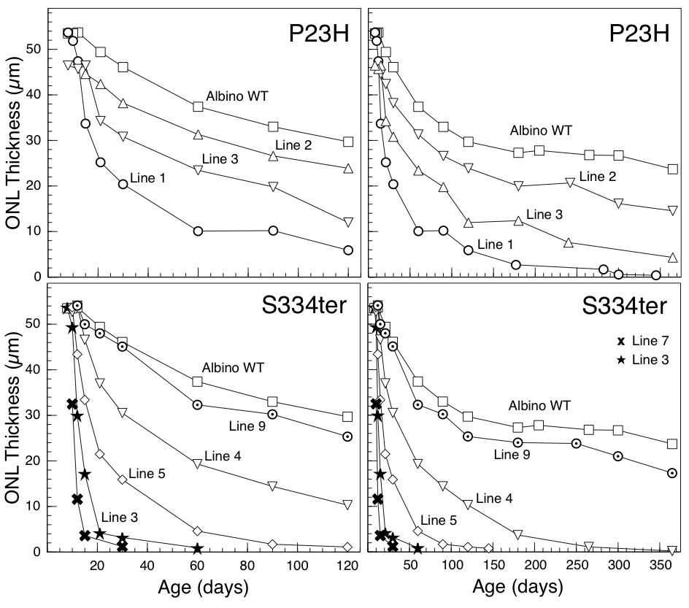

Return to Contents

Breeding and Use of Homozygotes

Experimental rats should carry one copy of the mutant transgene (hemizygotes). However, in most cases we will send you homozygous animals (with two copies of the mutant transgene) for breeding. We encourage you to breed homozygote pairs, which will give you a continuous supply of homozygotes for breeding purposes. To produce rats for experiments, however, we intend for you to breed transgenic homozygotes by normal Sprague-Dawley (SD) rats (see next paragraph) to produce litters in which all the animals are affected, and all carry one copy of the mutant transgene (hemizygotes). This breeding scheme will provide large numbers of affected, experimental animals and will avoid the need for PCR to determine which of the progeny is affected.
The transgenic rats are on the albino SD background, and you will need some of these rats for wild-type controls and for breeding purposes (see below). We do not supply SD rats, but these can be purchased from many commercial sources. The SD breeders originally used by Chrysalis/DNX to produce the transgenic rats were obtained from the Harlan Breeding Co. We have used these, as well as SD rats from Simonsen Breeding Laboratories in our experiments.
For two reasons, we recommend that homozygotes NOT be used for experimental studies, in most cases. These are 1) the two copies of the mutant transgene (as in homozygotes), in addition to the two copies of the normal rhodopsin gene, are even farther from the human genetic condition than a single mutant transgene and two normal copies of rhodopsin, as in the hemizygotes; and 2) we know that two copies of the transgene produce a faster rate of degeneration than a single copy in most of the lines, but we do not have complete baseline data for homozygotes as we do for the hemizygotes.
If exactly age-matched young animals are needed, the crossing of hemizygotes by SD rats will produce transgenic and non-transgenic littermates (approximately 50% of each genotype), which must be distinguished by PCR or some means (e.g., ERG) with every litter, or for experiments, simply use all animals in a litter, work on one eye and examine the other eye retrospectively to identify genotype (this means double the experimental work, but it can be done). If you need to do PCR, please contact us for primer sequences.
All of the lines are available as homozygotes except for S334ter lines 5 and 7, which have resisted our attempts to breed to homozyosity, presumably due to an undefined transgene insertional effect. With these two lines, you will need to cross the hemizygotes by SD rats, in which case 50% of the progeny will be transgenic, 50% non-transgenic. As described immediately above, you will need to distinguish the affected from unaffected rats by PCR or some other means.
Return to Contents

Production of Pigmented Transgenic Rats with Rhodopsin Mutations

If pigmented eyes are required for experiments, pigmented Long-Evans rats can be used instead of albino Sprague-Dawley rats in the breeding schemes described above. It should be noted that the eye pigmentation lowers retinal irradiance, which slows the rate of photoreceptor degeneration in the P23H lines, but not the S334ter lines (except Line S334ter-5). This is particularly important to consider for some experiments, since the P23H-3 degeneration rate is slowed to the extent that it almost appears identical to normal, wild-type retinas for up to 120 days of age. Comparison of the rates of degeneration can be made in the graphs below between albino (upper graphs, open symbols) and pigmented (lower graphs, filled symbols) transgenic rats of each line. This will be published in the near future, but the original description of the different rates of degeneration in the two pigmentation types was the following: Lowe, R.J., Duncan, J.L., Yang, H., Donohue-Rolfe, K.M., Matthes, M.T., Yasumura, D., LaVail, M.M.: Retinal degeneration is slowed by eye pigmentation in P23H but not in S334ter mutant rhodopsin transgenic rats. Invest. Ophthalmol. Vis. Sci. 46:ARVO E-Abstract 2300, 2005.

Rates of Degeneration in Albino (upper graphs) and Pigmented (lower graphs) Mutant Rhodopsin Transgenic Rats
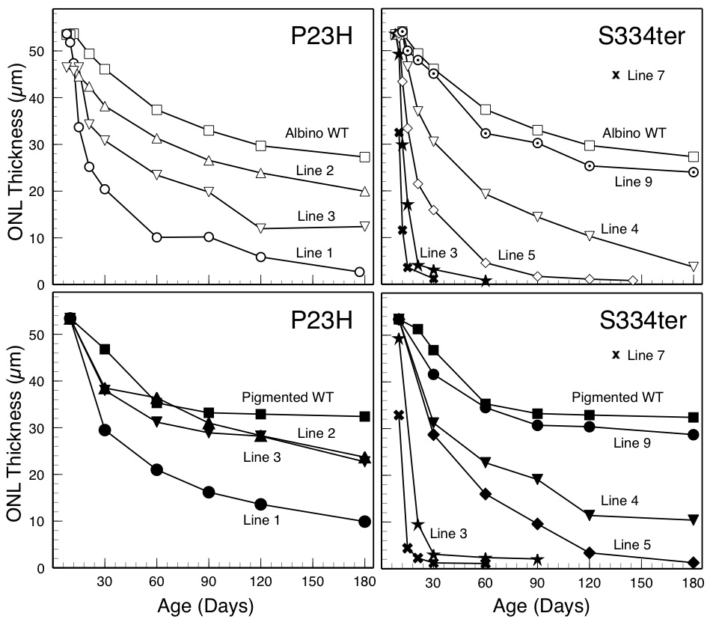
RCS Inbred and RCS Congenic Strains of Rats

Inbred RCS Rats

Inbred Royal College of Surgeons (RCS) rats are tan-hooded, pink-eyed animals that have inherited retinal dystrophy as a result of a primary genetic defect in the retinal pigment epithelium. The animals have been widely studied since their discovery in the 1930s. Our colony is the original inbred strain developed and named by Richard L. Sidman (Sidman and Pearlstein, Dev. Biol., 12:93-116, 1965). The gene defect has recently been identified as a deletion in the Mertk gene (D'Cruz, et al., Hum. Mol. Genet. 9:645-651, 2000). The histopathology of inherited retinal dystrophy, along with many early references to the animals can be found in LaVail and Battelle (Exp. Eye Res., 21:167-192, 1975).
Return to Contents

Congenic Strains of RCS Rats

In the 1970s and early 1980s, we produced congenic strains of RCS rats that are genetically similar to the inbred RCS strain, and these have been described previously (LaVail, et al., J. Hered. 66:242-244, 1975; LaVail, Invest. Ophthalmol. Vis. Sci. 20:671-675, 1981). These are 1) pink-eyed rats that are wild-type at the retinal dystrophy locus (+/+ at the rdy locus; strain designation RCS-rdy⁺) that serve as control animals for the pink-eyed dystrophic, inbred RCS strain; 2) pigmented (black-hooded) rats, as well, since eye pigmentation is sometimes needed for certain experiments. The strain designation for the pigmented dystrophic rats is RCS-p⁺; and 3) pigmented, non-dystrophic line for use as normal controls for pigmented dystrophic rats, and its strain designation is RCS-rdy⁺p⁺.
Return to Contents
Available Lines of RCS Rats:

The lines that are available are the following:

RCS/Lav Inbred, pink-eyed, dystrophic rats
RCS-rdy⁺/Lav Congenic, pink-eyed, wild-type, non-dystrophic rats
RCS-p⁺/Lav Congenic, pigmented, dystrophic rats
RCS-rdy⁺p⁺/Lav Congenic, pigmented, wild-type, non-dystrophic rats

The laboratory code “Lav” has been assigned to us by the Institute of Laboratory Animal Research (ILAR). While we and others have not used this in the past, its use as a part of the strain name is now recommended (http://www.informatics.jax.org/mgihome/nomen/strains.shtml).
Return to Contents
Breeding Schemata for RCS and RCS Congenic Strains

We provide littermate breeding pairs of each of the lines. The inbred RCS rats are maintained by brother x sister breeding to maintain their inbred status. You should breed the congenic strains the same way. However, after about 6-8 generations, the animals should be backcrossed to the inbred RCS line several times to maintain the congenic status (rather than to develop a substrain). This backcrossing can be fairly complex, so it is generally easier to obtain animals from us again at a later date. To avoid developing substrains and to maintain the congenic status, we recommend that you allow the congenic animals that we send to produce as many litters as possible before choosing littermates to use for new breeder pairs. In this way, you will delay the development of a substrain, which occurs after about 8 generations of breeding. Return to Contents

Degeneration Rates in RCS and Pigmented RCS Rats

Pigmented dystrophic animals (strain designation RCS-p⁺) have a slower rate of degeneration than the pink-eyed rats and a significant hemispheric difference in the rate of degeneration in the peripheral retina. As described in LaVail and Battelle (Exp. Eye Res., 21:167-192, 1975) and as shown on the graphs below, the rate of degeneration and loss of photoreceptor cells in the pigmented dystrophic retinas is slowed by about 7-10 days in the central/posterior retina, and significantly more in the peripheral retina in superior hemisphere (although not slowed at all from the pink-eyed rate in the inferior retina along the vertical meridian).

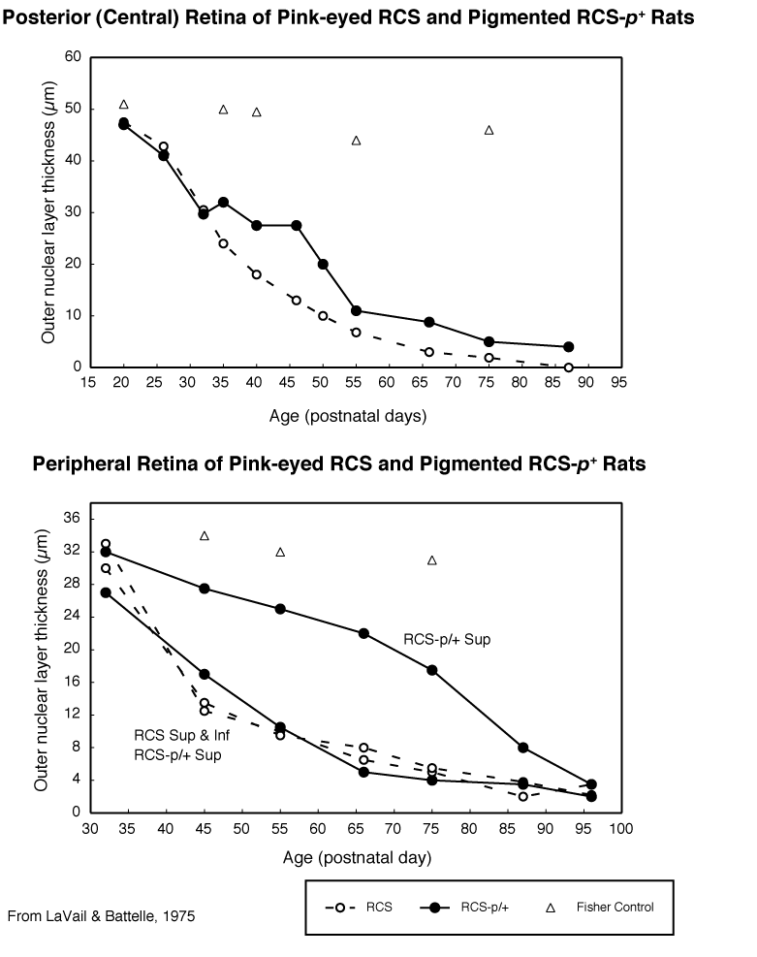
Return to Contents

Contact Information

Please feel free to contact any or all members of our group at any time. We want to facilitate sending you the most appropriate rat models for your studies.

For discussion of matters relating to the genetics and phenotypes of retinal degeneration in the rat models, planning of experiments, choice of lines or strains, large special requests, requests for collaborative studies, etc., please contact Dr. Matthew LaVail.

For requests of animals, availability of rats for shipping, husbandry issues, breeding schemata, genotyping and arranging shipping, please contact Dr. Michael Matthes, or in his absence, Dr. Matthew LaVail.

In the absence of Dr. Matthes or Dr. LaVail, or to ask about specific surgical, injection, fixation or histological methods, please feel free to contact Mr. Douglas Yasumura.

Matthew M. LaVail, Ph.D. Michael T. Matthes, Ph.D.
Beckman Vision Center Beckman Vision Center
UCSF School of Medicine UCSF School of Medicine
San Francisco, CA 94143-0730 San Francisco, CA 94143-0730
Phone: (415) 476-4233 Phone: (415) 502-1098 or (415) 514-4238
FAX: (415) 476-0709 FAX: (415) 476-0709
e-mail: matthew.lavail@ucsf.edu e-mail: michael.matthes@ucsf.edu

Douglas Yasumura
Phone: (415) 514-4238
e-mail:
douglas.yasumura@ucsf.edu

Return to Contents
6/30/11

